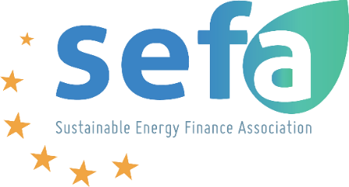

**SEFA and Solar Heat Europe follow-up webinar: Boosting investment in solar thermal energy by aggregating projects – 13th of March from 10:00 to 11:30**

Solar Heat Europe (SHE) and Sustainable Energy Finance Association (SEFA) were very pleased with the first joint working session held in January, tackling the financing of renewable heat in the residential sector. It was the first opportunity for members to engage in a common discussion and draw several ideas on ways to improve the financing of solar thermal energy in Europe.

One of these findings is that solar thermal projects need to be aggregated if they are to be attractive to investors. As a result, the two associations have decided to organize a new working session, focusing on ways of aggregating projects to ultimately facilitate the flow of finance to renewable heat ventures.

So, to build on the momentum created in January, SEFA and Solar Heat Europe are inviting you to this second working session to explore in greater depth the possibilities of cooperation to help decarbonize the European heating energy mix. This second webinar will take place the 13th March 2025 between 10:00 and 11:30.

Join us for an insightful webinar that could open the door to more exciting discussions to come.

**10:00 - 10:10: Introductory remarks**

**Ms. Angeliki (Lina) Konstantinopoulou** (Executive Director of SEFA)

**Ms. Valérie Séjourné** (Managing Director of Solar Heat Europe)

**10:10 - 10:30: Conclusions from the previous meeting and hypotheses to explore**

**10:30 - 10:20: Discussion among the members to boost investment in solar thermal projects**

**11:20 - 11:30: Concluding remarks**

**Register here:**

<https://events.teams.microsoft.com/event/5fa310ae-c3b8-403c-9766-582a34b16fd3@536cc068-e087-492e-b1c7-ba8fdc879ae9>